**Download and Installation of Power BI**

**Steps to Download Power BI**

The steps on how to download and install the latest version of Power BI for Windows and Mac:

**Prerequisites for Windows**

* Operating system: Windows 7 SP1 or later, Windows 8.1, or Windows 10
* Processor: 1 gigahertz (GHz) or faster processor
* Memory: 4 gigabytes (GB) RAM
* Hard disk space: 4 GB available disk space
* Display: 1024 x 768 screen resolution
* Internet Explorer 11 or later, or Chrome, Firefox, or Edge

Steps on how to download and install Power BI for Windows

1. Go to the Power BI website: https://powerbi.microsoft.com/en-us/ and click Download.
2. Select Windows and then click Download.
3. Run the installer file and follow the on-screen instructions.
4. Once the installation is complete, open Power BI Desktop.

Prerequisites for Mac

* Operating system: macOS 10.12 Sierra or later
* Processor: Intel Core i5 or equivalent
* Memory: 4 GB RAM
* Hard disk space: 4 GB available disk space
* Display: 1024 x 768 screen resolution
* Safari 11 or later

Steps on how to download and install Power BI for Mac

1. Go to the Power BI website: https://powerbi.microsoft.com/en-us/ and click Download.
2. Select Mac and then click Download.
3. Open the installer file and follow the on-screen instructions.
4. Once the installation is complete, open Power BI Desktop.

Steps that are the same for both Windows and Mac

* Once Power BI Desktop is open, you will be prompted to sign in with your Microsoft account.
* If you do not have a Microsoft account, you can create one for free.
* Once you are signed in, you can start creating reports and dashboards.

**Additional steps for Windows**

* If you are using a corporate network, you may need to contact your IT administrator to get permission to install Power BI.
* You can also install Power BI as a Microsoft Store app. To do this, open the Microsoft Store app and search for "Power BI". Click Get and then follow the on-screen instructions.

**Additional steps for Mac**

* If you are using a corporate network, you may need to contact your IT administrator to get permission to install Power BI.
* You can also install Power BI as a disk image (.dmg) file. To do this, download the .dmg file from the Power BI website and then double-click it to open it. Drag the Power BI icon to the Applications folder.

**Connecting to Data and Creating Visuals in Power BI Desktop**

**Data Connection to Access Source Files**

The initial step in using Power BI Desktop involves establishing a data connection to access the desired source files. To connect Power BI Desktop to a source file and create visuals, you will need the respective source file. This can be achieved by navigating to the "Get Data" option within the Power BI Desktop interface.

Within Power BI Desktop, you can accomplish this by selecting the "Get Data" option available in the interface. Upon launching Power BI Desktop, a dialog box will appear, providing you with the opportunity to choose the "Get Data" option. From there, you can select the desired data source from a wide range of available options.

**Power BI Desktop Options:**

To ensure consistent interpretation of data formats and limiters on your machine, it is important to configure the options and settings in Power BI Desktop. To access these settings, go to the "File" menu, then "Options and Settings," and select "Options."

**Regional Settings:**

In the "Options" popup, navigate to the "Current File Options" and go to "Regional Settings." Ensure that the locale, which affects how numbers and data formats are interpreted, is set to "English, United States." Adjust it if necessary.

**Opening Source File:**

Return to the Home ribbon in Power BI Desktop and click on "Get Data" to open the Get Data menu. Here, you will find a variety of connectors available. For an Excel file, select the "Excel workbook" connector and click "Connect."

**Selecting Source File:**

Navigate to the folder where the Excel file is stored, select the file, and click "Open." This will open the navigator, which allows you to view and select specific information from the source file.

**Previewing and Selecting Data:**

In the navigator, you can preview the content of the sheet(s) in the Excel file. If multiple sheets exist, select the desired sheet by ticking the corresponding box. Choose between loading the data directly into the data model or accessing the query editor for data transformation.

**Query Editor:**

Power BI Desktop offers two integrated tools: the data model, where visuals and analysis are created, and the query editor, where data preparation steps are performed. Typically, it is recommended to use the "Transform Data" option in the query editor to clean and shape the data.

**Data Preparation:**

In the query editor, you can perform various data preparation tasks such as removing columns, changing formats, and cleaning data. Apply the necessary steps to ensure the data is in the desired format for analysis and visualization.

**Loading Data:**

Once data preparation is complete, you can choose to load the data directly into the data model or access the query editor for further transformations. Typically, the transform data step is used before loading the data into the model.

**Data View:**

After loading the prepared data, you can switch to the data view to check the columns, formats, and cleaned data. Ensure that the data is accurate and ready for analysis or visualization.

**Report View and Visual Creation:**

To create visuals, switch to the report view. Here, you can drag and drop visuals onto the canvas and design your reports and dashboards.

By following these steps, you can connect Power BI Desktop to a source file, perform data preparation in the query editor, and create visuals in the report view, allowing you to analyze and visualize your data effectively.

**Connecting and Preparing the Source File in Power BI Desktop**

To work with the "gdp_countries.xlsx" file in Power BI Desktop and create visuals, you need to connect and prepare the source file. Here's a step-by-step guide:

**Opening the Source File:**

Navigate to the home ribbon in your Power BI Desktop project.

Go to "Get Data" and click on the option located in the upper part of the interface.

**Accessing the Get Data Menu:**

Upon clicking, the "Get Data" menu will open, showing an overview of available connectors in Power BI Desktop.

Connectors are the logic that enables the connection between Power BI Desktop and specific file types.

Since the downloaded file is an Excel file, the default selection of "Excel workbook" is appropriate.

Click "Connect" to proceed.

**Selecting the Source File:**

Locate the folder where you have stored the "gdp_countries.xlsx" file.

Select the file and click "Open".

**Navigating the Source File:**

The navigator will open, allowing you to view the information within the source file and make specific selections.

In the case of an Excel file, if there are multiple sheets, you can choose a specific sheet by ticking the box next to its name.

For this example, as there is only one sheet, the selection does not make a significant difference.

**Previewing the Content:**

In the right part of the interface, you will see a preview of the content of the selected sheet.

If there were multiple sheets, you could select a different sheet and view its content.

By ticking the box next to the sheet name, two options become available: "Load" and "Transform Data".

These options will be explored in detail throughout the course.

**Integrated Tools:**

Power BI Desktop consists of two integrated tools:

The data model part where visuals are created and analysis is conducted.

The power query or query editor for data preparation.

The query editor is where data cleansing steps, such as removing columns, changing formats, and cleaning data, are performed.

**Loading Data:**

Decide whether to directly load the data into the data model or access the query editor first.

In data analytics projects, it is common to use the "Transform Data" option first to cleanse the data.

To access the query editor, select the "Transform Data" option.

**Working in the Query Editor:**

In the query editor, you can perform various data preparation tasks.

In this starting project, we focus on creating visuals, so we won't delve deep into the interface and options available.

The main purpose is to get you started with Power BI Desktop.

**Overview of the Query Editor:**

The query editor appears as a separate window within Power BI Desktop.

It shows an overview of the loaded data in the center.

In this case, the loaded data includes gross domestic product (GDP) data for different years and countries.

It is important to review the data for errors or unnecessary information to ensure that only the required data is loaded into the data model for analysis or visualization.

**Removing Unnecessary Columns:**

Analyze the columns in the query editor and identify those that are not necessary for analysis.

For example, columns two, three, and four may contain information about GDP in US dollar billions, which is not needed for the current project.

Select one of the unnecessary columns, go to the home ribbon, and click on "Remove Columns" in the "Managed Columns" area.

**Applied Steps and Removing Columns:**

In the query settings on the right side, you can see the applied steps that have been automatically applied by Power BI Desktop.

The last step should be the removal of the unnecessary columns.

If you accidentally remove a wrong column or perform an unwanted step, you can select the corresponding step and click the "X" button to undo or remove it.

**Selecting and Removing Columns:**

To remove multiple columns, press and hold the control button while selecting the desired columns.

After selecting the columns, go to the home ribbon and click on "Remove Columns" to remove them.

**Checking Values and Filtering Data:**

It is important to check if the values in each column are correct and do not contain any errors.

In the GDP column, there may be "n/a" values indicating missing data for certain countries and years.

To filter out this information, go to the corresponding column, click on the filter menu button located to the right of the column name.

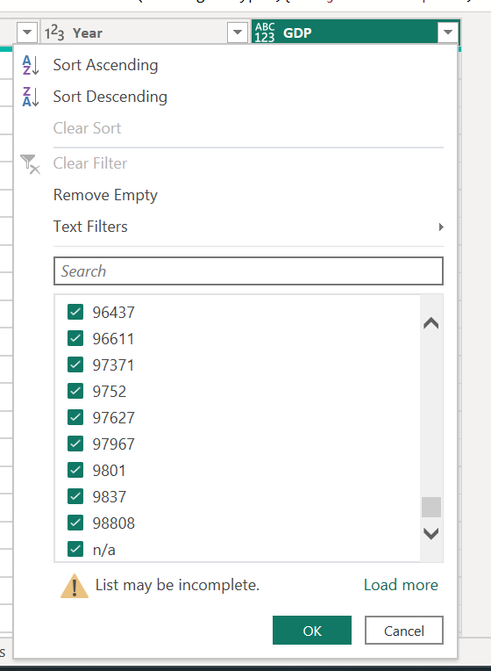

Scroll down to find the "n/a" value and untick the box to remove it from the data set.

**Data Format Check:**

Verify the data format for each column, as indicated by the symbols to the left of the column names.

For example, "ABC" represents text, and "123" represents a whole number.

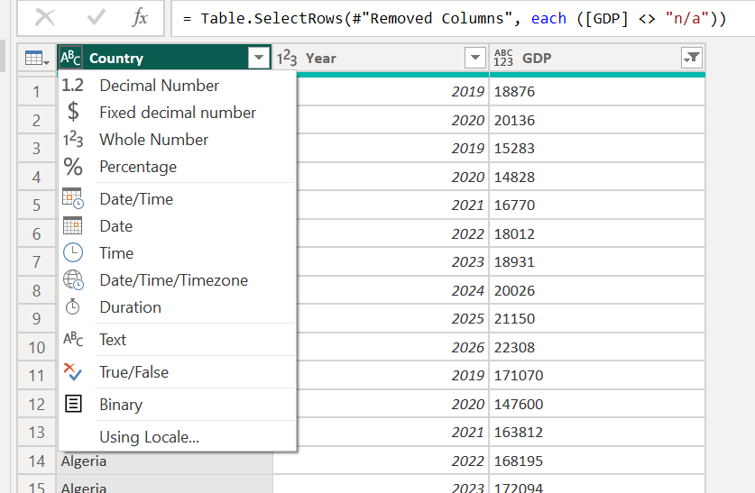

Ensure that the formats align with the nature of the data in each column.

**Closing and Applying Changes:**

Once the data preparation steps are completed, go to the home ribbon and click on the "Close & Apply" button located in the upper part of the interface.

By doing so, the data is not only loaded into the data model, but only the prepared data is loaded.

**Viewing the Loaded Information:**

Open the data view, which can be found in the "View" tab, to verify the loaded information.

The data view will display only the required columns and cleared rows, adhering to the logic of loading only necessary information into the project.

**Creating Visuals:**

Return to the report view by selecting it from the available views.

In the report view, you can now drag and drop the desired visuals to start creating visual representations of the data.

These steps guide you through connecting and preparing the "gdp_countries.xlsx" source file in Power BI Desktop, ensuring that the data is ready for analysis and visualization.

**Creating Visuals for the "gdp_countries.xlsx" Dataset in Power BI Desktop**

To visualize the data in the "gdp_countries.xlsx" dataset using Power BI Desktop, follow these steps:

1. Accessing Visualizations:
   * Locate the Visualizations column on the right side of the screen.
   * Select an appropriate visual from the available options.
   * For example, choose the stacked column chart.

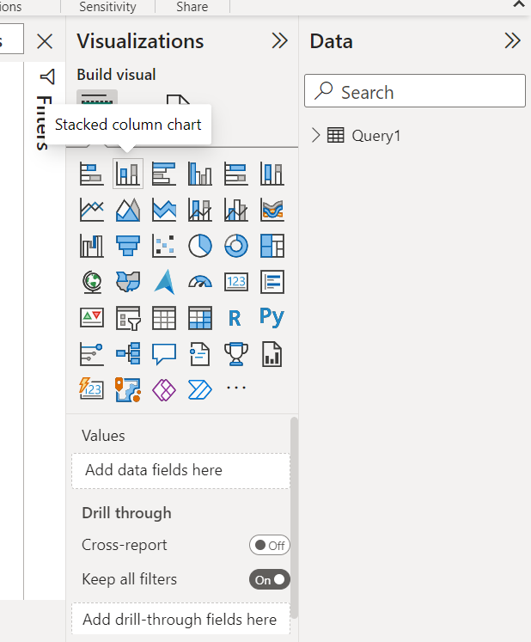

1. Customizing the Visual:
   * Manipulate the visual by moving and resizing it.

* + Collapse or expand menus, such as the filters menu, as needed.

1. Adding Data to the Visual:
   * Use the Fields column on the right side.
   * Open the Query1 connection to view the fields extracted from the Query Editor.
   * Drag and drop the desired fields into dedicated areas of the visual.
   * For example, drag and drop the "year" field to the x-axis and the "GDP" field to the y-axis.

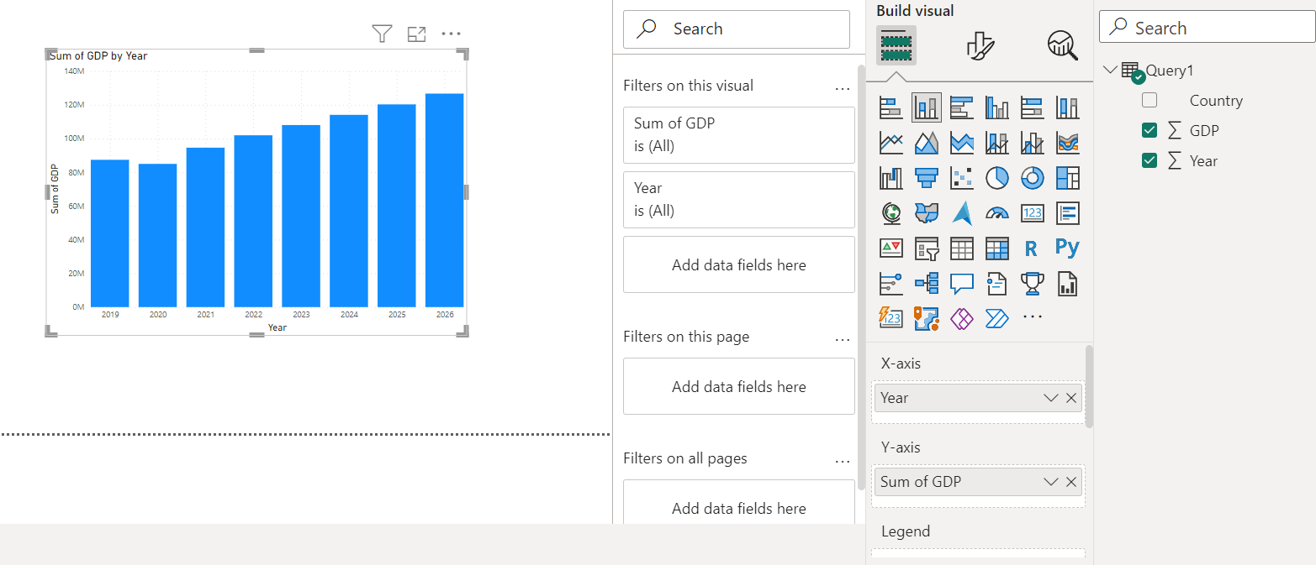

1. Incorporating Country Differentiation:
   * To differentiate data by country, add the "country" field to the legend area of the chart.
   * Each country will be represented by a different color.

1. Applying Filters:
   * Reduce the number of displayed countries by applying a filter.
   * Collapse or expand the filters column if necessary.
   * Open the filter menu for the "country" field.

* + Choose the "Top N" filter option to show only the top countries based on a specific value, such as GDP.

* + Drag and drop the "GDP" field into the filter and apply the filter.

* + In this example, only the top five countries (China, Germany, Japan, United Kingdom and the United States) will be shown.

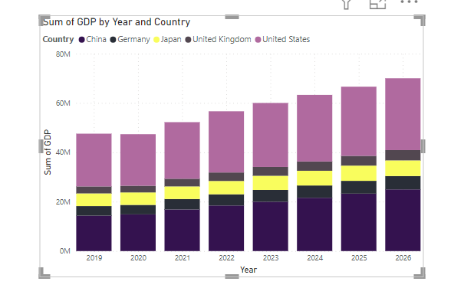

1. Changing Visual Types:
   * Modify the visual type by selecting the current visual.
   * Choose a different visual from the available options.
   * For instance, select the map visual to display a world map.
2. Enabling Map Visuals (if necessary):
   * If the map visual does not load, go to the Options menu.
   * Navigate to File > Options and settings > Options.
   * Access the security menu and enable the "Use Map and Filled Map visuals" option.
   * Click OK to apply the changes.

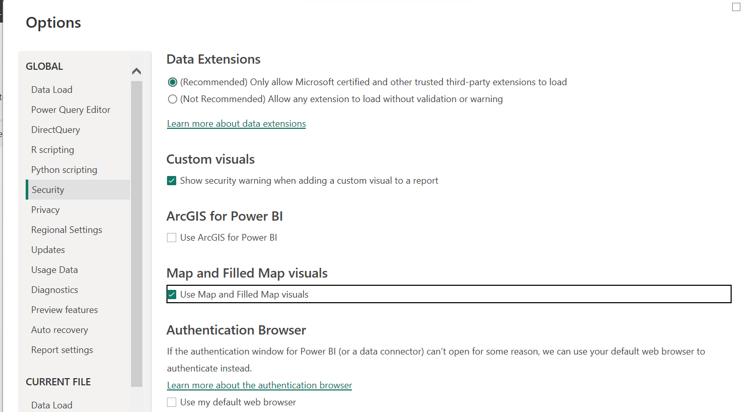

* + Switch back to the column chart and then reselect the map visual to load it successfully.

1. Refining the Map Visual:
   * Remove the year differentiation from the legend area, if desired, for clarity.

* + Click the X symbol to remove the field from the legend.
  + This will leave only the top five countries as bubbles on the map.

1. Adding Data Labels:
   * Navigate to the Format menu by going to the Visualizations column.

* + Turn on the category labels to display the country names.
  + This will add data labels to the bubbles showing the corresponding country names.

1. Saving the Project:
   * To save the project and avoid losing your work, click the Save option.
   * Choose a location to save the project, provide a file name, and save it as a .pbix file.
   * The .pbix file is the Power BI project file.

By following these steps, you can create visuals and effectively present the data from the "gdp_countries.xlsx" dataset using Power BI Desktop.

Difference Between Excel and Power BI

Excel and Power BI serve different purposes and have distinct strengths. Here are the key differences between the two tools:

When to Use Excel:

1. Quick Calculations: Excel is suitable for performing rapid calculations in smaller data sets, such as calculating sums or averages.
2. Tabular Reports: If you need reports in a tabular format and your data size is manageable, Excel can be used effectively.
3. Single Tool Approach: Excel is a good choice if you prefer to handle all calculations, charts, and data analysis within a single tool.

When to Use Power BI:

1. Handling Big Data: Power BI is designed to handle large and complex data sets that exceed Excel's limitations. It is the preferred option when working with big data.
2. Interactive Visualizations: Power BI offers advanced capabilities for creating interactive visualizations. It excels at creating, switching, and selecting data with its drag-and-drop fields feature.
3. Extensive Visual Options: If you require a wide range of visually appealing and comprehensive visualizations, Power BI surpasses Excel in providing a rich set of visual options.
4. Collaboration: Power BI facilitates easy and efficient collaboration within projects. The Power BI tool set, including the connection between Power BI Desktop and Power BI Pro, enables seamless collaboration, whereas sharing Excel files can be more cumbersome.

Excel and Power BI complement each other, catering to different needs and scenarios. While they may have some overlapping functionalities, the distinct advantages of each tool become apparent based on the specific requirements of your project.

Flow of Content in the Course

1. Introduction and Course Preparations:
   * Overview of Power BI Desktop workflow and project steps.
   * Exploring the interface and recommended settings.
2. Query Editor - Data Preparation:
   * Working on columns, extracting information, and deleting columns.
   * Handling rows and fixing errors.
   * Formatting and preparing data for further use.
3. Query Editor - Data Transformation:
   * Changing the structure of the project.
   * Data modeling and creating a data schema.
   * Applying advanced concepts for larger data analysis projects.
4. Data Model:
   * Data Analysis Expressions (DAX) for data analysis tasks.
   * Establishing relationships between tables.
   * Creating reports and visualizations on report pages.
5. Power BI Pro and Collaboration:
   * Transitioning from Power BI Desktop to the cloud.
   * Sharing and collaborating using Power BI Pro.
   * Managing projects with workspaces, gateways, and apps.
6. Power BI Mobile:
   * Exploring the Power BI Mobile app.
   * Accessing Power BI Pro projects on mobile devices.

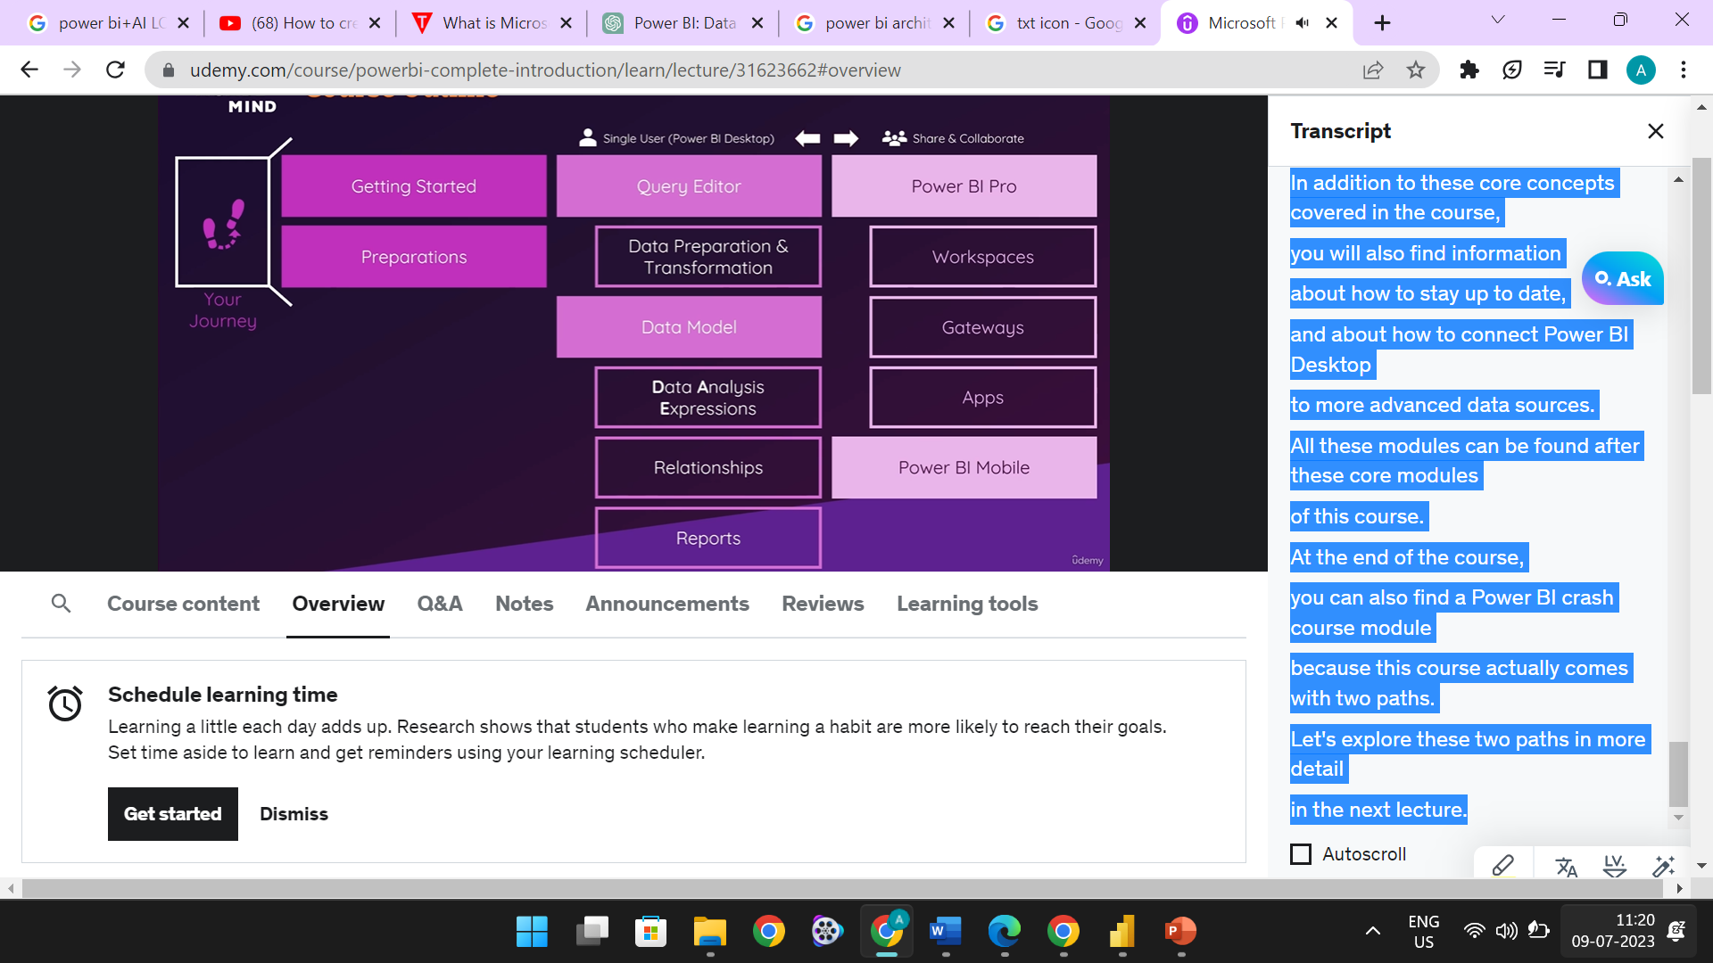

Additional Content:

* Staying up to date with Power BI.
* Connecting Power BI Desktop to advanced data sources.

Power BI Crash Course Module:

* An additional module for a quick overview and recap of Power BI concepts.

The course covers the complete workflow of working with Power BI Desktop, from data preparation and transformation to creating reports and visualizations. It also delves into the collaborative features of Power BI Pro and explores the mobile app for accessing projects on the go. Additional content and a crash course module provide further resources for staying updated and connecting to advanced data sources.

Course Path Options:

1. Standard Approach:
   * Start with the introduction module.
   * Progress through the course step by step, module by module.
   * Dive into dedicated areas and contents of Power BI Desktop gradually.
   * Conclude with the Power BI Desktop summary module for a comprehensive review of core concepts.
   * Use the summary module for future knowledge refreshment.
2. Summary Approach:
   * Begin with the introduction module.
   * Skip ahead to the Power BI Desktop summary module at the end of the course.
   * Efficiently learn all core Power BI Desktop concepts, from data connection to visual creation.
   * Gain the necessary skills to use Power BI Desktop in your own project.
   * Consider revisiting the full course for a deeper understanding of Power BI Desktop features and transitioning to Power BI Pro.

Both approaches have their merits, but it is recommended to follow the standard approach if time allows. The full course provides a comprehensive exploration of Power BI Desktop, including its advanced features and integration with Power BI Pro. The summary approach offers a faster route to acquiring essential knowledge but may benefit from revisiting the full course for a more comprehensive understanding in the future.